Nama : Viona Paramitha

Kelas : 5C

NIM : 18090097

Praktikum 3

1. Source Code : view-form-matakuliah.php >>> application/views

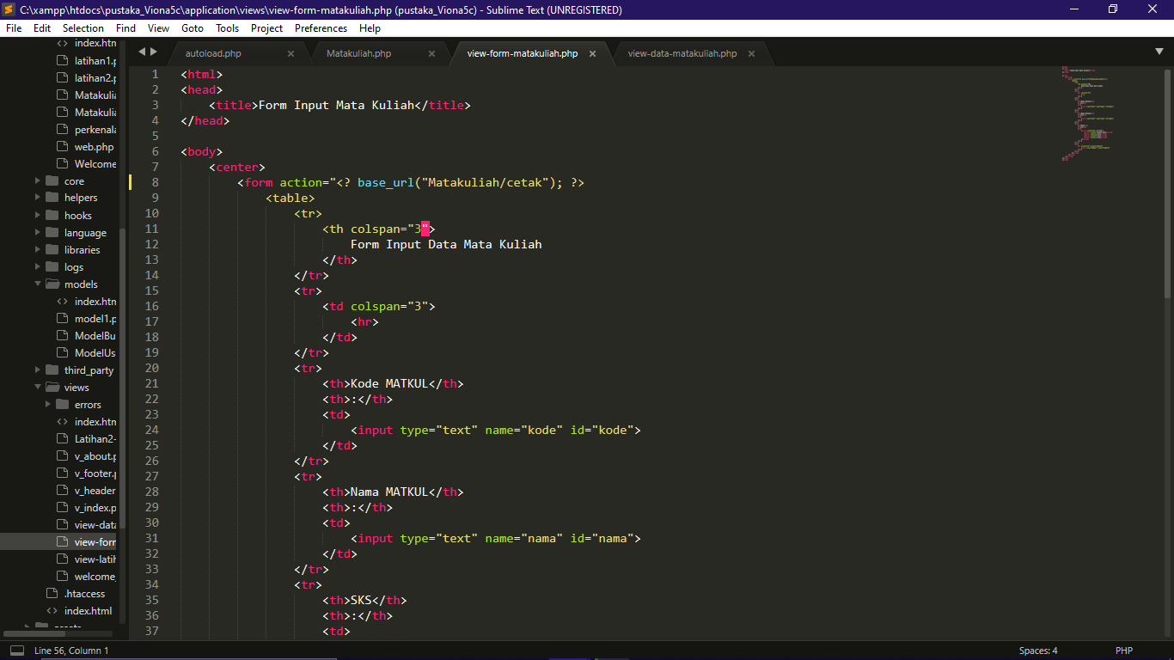

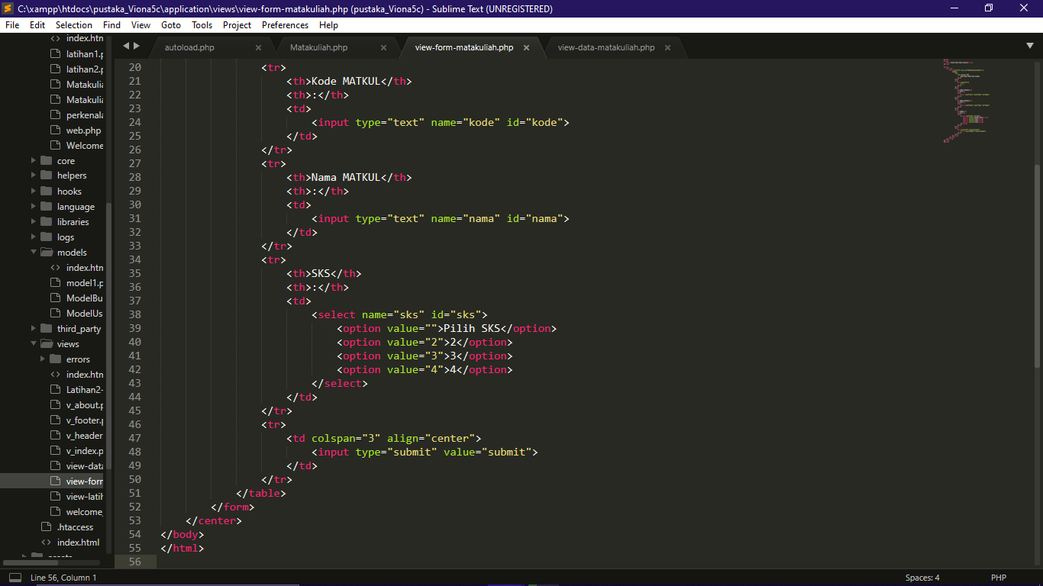

Source Code : view-data-matakuliah.php >>> application/views

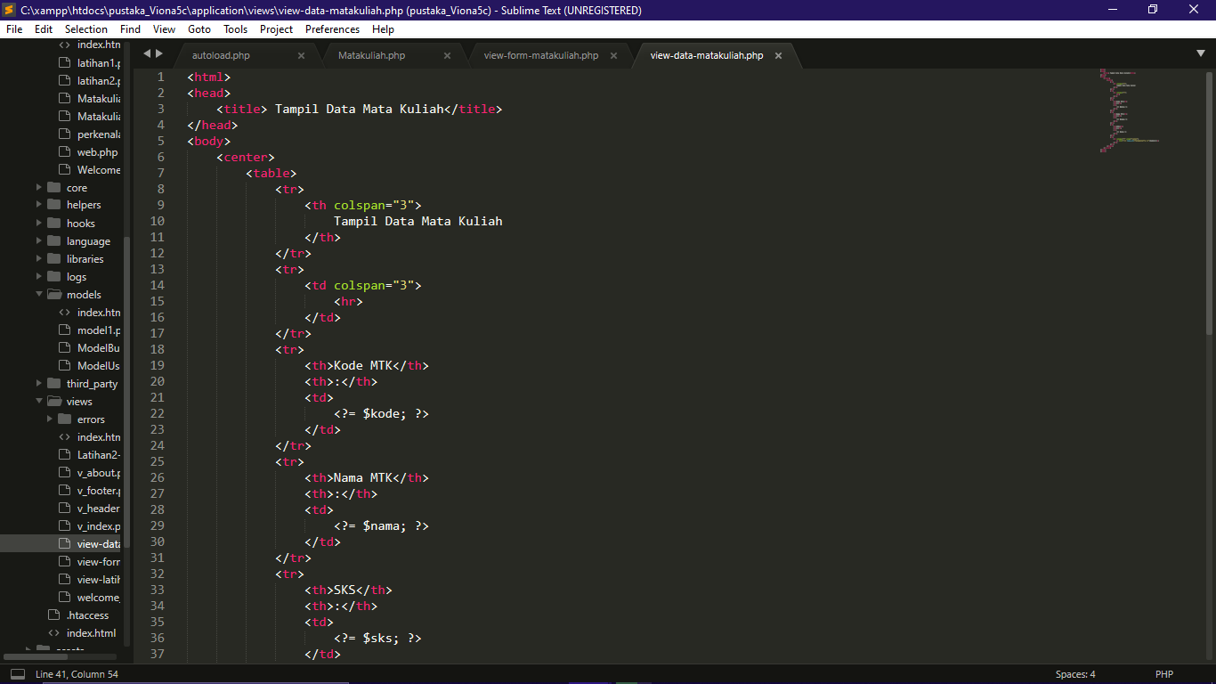

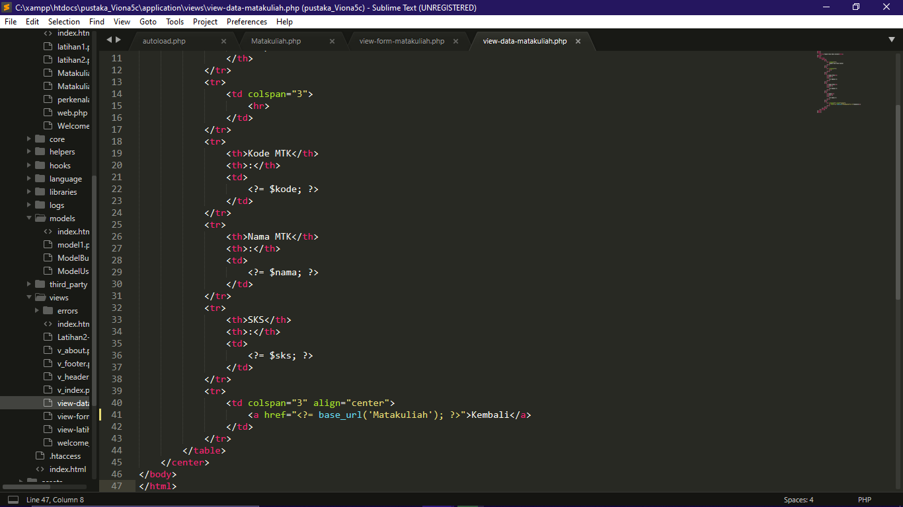

Source Code : matakuliah >>> application/controllers

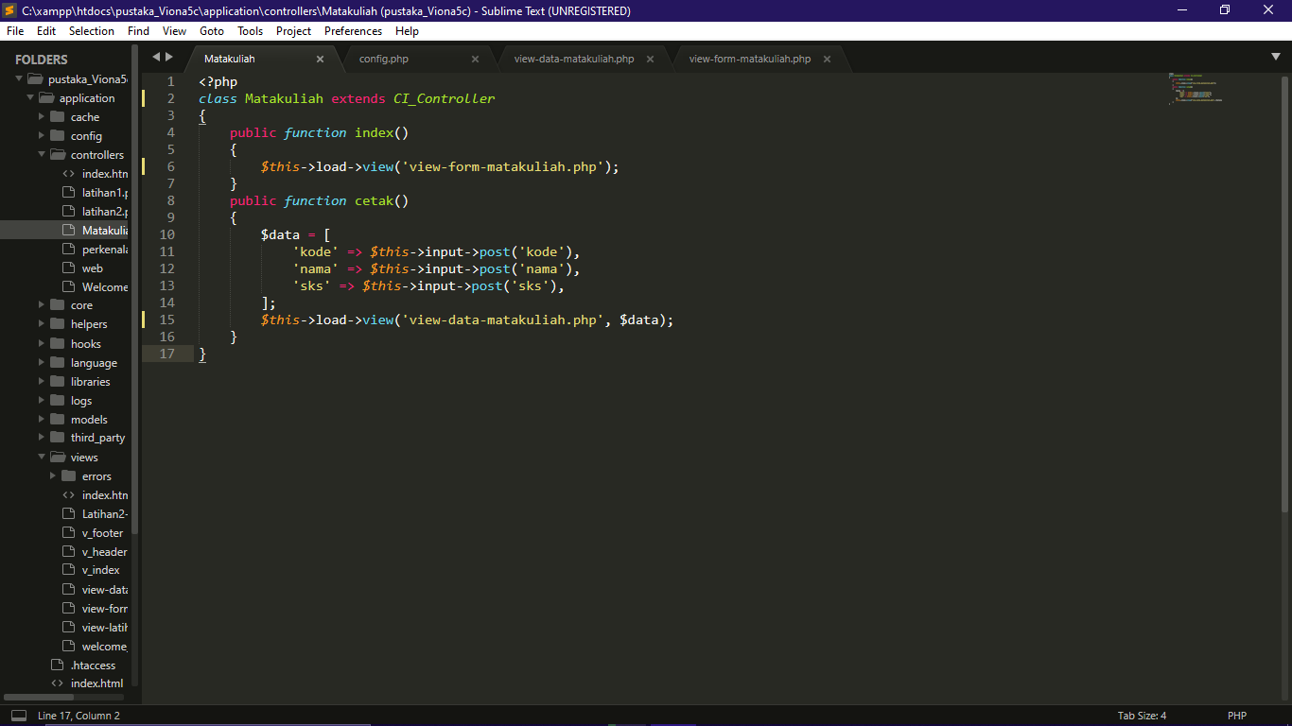

1. Hasil URL : <http://localhost/pustaka_Viona5c/index.php/Matakuliah>
2. Capture Hasil :

